**Solution**

**Overview**

Given two arrays spells and potions, we need to find for each spell how many potions will form a **successful pair**.  
A spell and potion pair is considered successful if the product of their strengths is at least success.

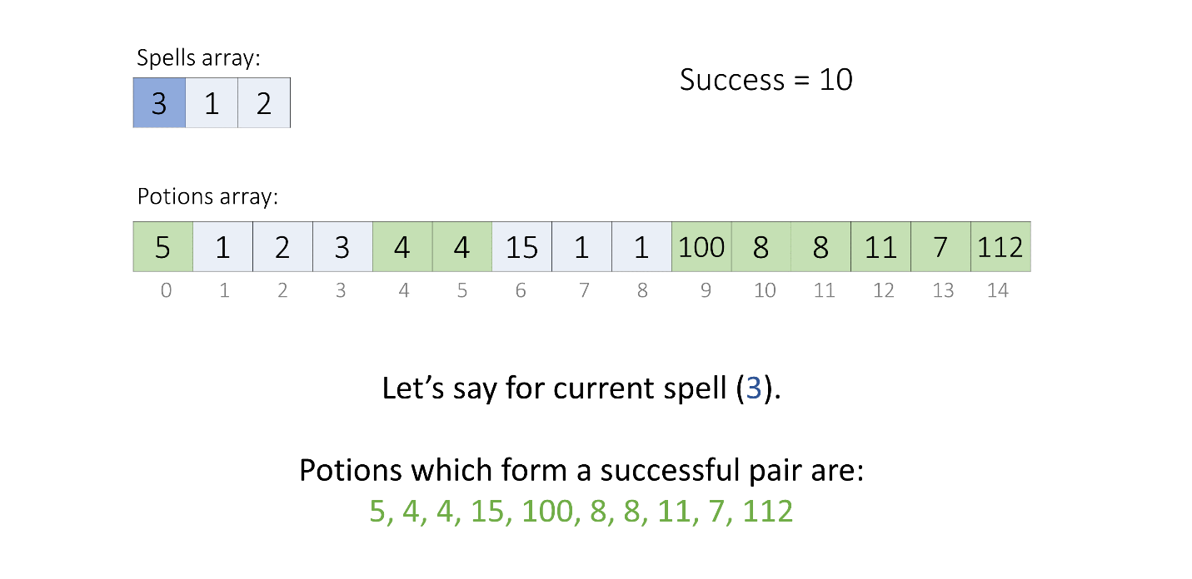

**Approach 1: Sorting + Binary Search**

**Intuition**

Let's assume for a given spell\text{spell}spell, we have, spell∗a = success\text{spell} * \text{a = success}spell∗a = success  
So, for all x\text{x}x, where x≥a\text{x} \geq \text{a}x≥a, the result, spell∗x\text{spell} * \text{x}spell∗x will always be greater than or equal to success\text{success}success.

This suggests if we know the minimum potion, minPotion in the potions array, whose product with a given spell is more than or equal to success, then all the potions which are greater than minPotion will also form successful pairs with it.

Now let's find what will be the value of minPotion.  
The product of spell and minPotion will be at least success.

  ⟹  spell∗minPotion≥success\implies \text{spell} * \text{minPotion} \geq \text{success}⟹spell∗minPotion≥success  
  ⟹  minPotion≥success / spell\implies \text{minPotion} \geq \text{success / spell}⟹minPotion≥success / spell  
  ⟹  minPotion=ceil(success / spell)\implies \text{minPotion} = \text{ceil(success / spell)}⟹minPotion=ceil(success / spell)

Now to easily search for a value in an array, we can use **binary search** if the array is sorted.  
Thus, we will sort the potions array and search the first index index of minPotion or the element just greater than minPotion.

As we know all the potions bigger than minPotion will also form a successful pair with the given spell,  
Thus, all the potions whose product with spell is greater than or equal to success will be all the elements from index index till the last element.

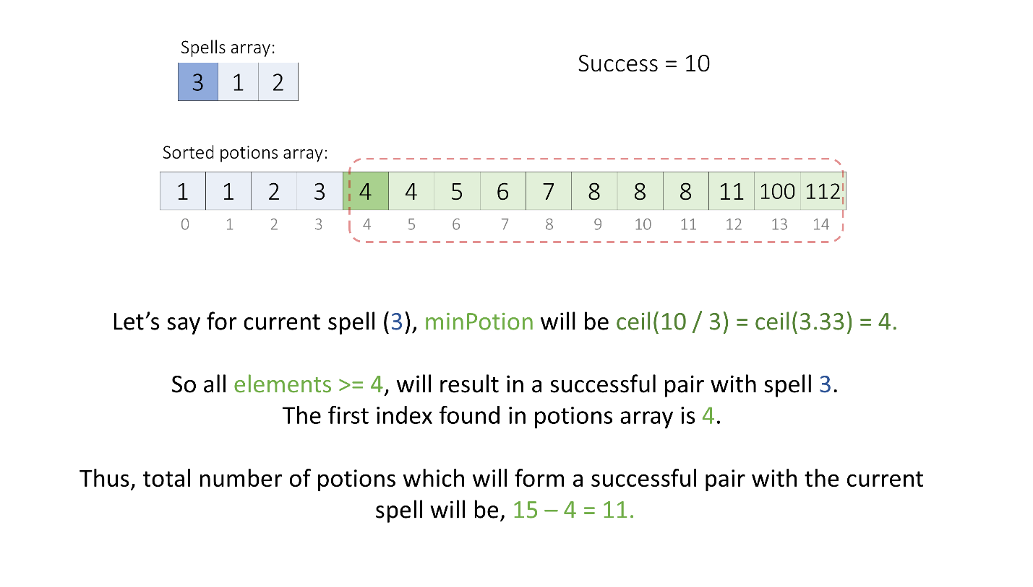

This sums up that, we will sort the potions array, then for each spell in the spells array, using binary search we will find the index as discussed and count all the potions from index till the end as successful potions for the current spell.

**Algorithm**

1. Sort the potions array in ascending order.
2. Initialize variables:
   * answer, an array to store the result.
   * m, length of the potions array.
   * maxPotion, the maximum value in the potions array.
3. For each spell in the spells array:
   * Calculate the minimum potion strength required to make the spell successful as minPotion using the formula minPotion = ceil(success / spell).
   * If minPotion is greater than maxPotion, store 0 in the answer array and continue to the next spell.
   * Otherwise, find the index of the first element in the potions array that is greater than or equal to minPotion using the inbuilt lower bound methods like lower_bound(), bisect.bisect_left(), sort.SearchInts(), etc. or by implementing it on your own.
   * Calculate the number of successful pairs possible for the current spell as (m - index).
   * Store the result in the answer vector.
4. Return the answer array which contains the number of successful pairs for each spell.

**Implementation**

class Solution {

public:

    vector<int> successfulPairs(vector<int>& spells, vector<int>& potions, long long success) {

        // Sort the potions array in increasing order.

        sort(potions.begin(), potions.end());

        vector<int> answer;

        int m = potions.size();

        int maxPotion = potions[m - 1];

        for (auto& spell : spells) {

            // Minimum value of potion whose product with current spell

            // will be at least success or more.

            long long minPotion = ceil((1.0 * success) / spell);

            // Check if we don't have any potion which can be used.

            if (minPotion > maxPotion) {

                answer.push_back(0);

                continue;

            }

            // We can use the found potion, and all potion in its right

            // (as the right potions are greater than the found potion).

            auto index = lower_bound(potions.begin(), potions.end(), minPotion) - potions.begin();

            answer.push_back(m - index);

        }

        return answer;

    }

};

**Complexity Analysis**

Here, nn*n* is the number of elements in the spells array, and mm*m* is the number of elements in the potions array.

* Time complexity: O((m+n)⋅log⁡m)O((m + n) \cdot \log m )*O*((*m*+*n*)⋅log*m*)
  + We sort the potions array which takes O(mlog⁡m)O(m \log m)*O*(*m*log*m*) time.
  + Then, for each element of the spells array using binary search we find the respective minPotion which takes O(log⁡m)O(\log m)*O*(log*m*) time. So, for nn*n* elements it takes O(nlog⁡m)O(n \log m)*O*(*n*log*m*) time.
  + Thus, overall we take O(mlog⁡m+nlog⁡m)O(m \log m + n \log m)*O*(*m*log*m*+*n*log*m*) time.
* Space complexity: O(log⁡m)O(\log m)*O*(log*m*) or O(m)O(m)*O*(*m*)
  + The output array answer is not considered as additional space usage.
  + But some extra space is used when we sort the potions array in place. The space complexity of the sorting algorithm depends on the programming language.
    - In Python, the sort() method sorts a list using the Timsort algorithm which has O(m)O(m)*O*(*m*) additional space where mm*m* is the number of the elements.
    - In C++ and Swift, the sort() function is implemented as a hybrid of Quick Sort, Heap Sort, and Insertion Sort, with a worst-case space complexity of O(log⁡m)O(\log m)*O*(log*m*).
    - In Java, Arrays.sort() is implemented using a variant of the Quick Sort algorithm which has a space complexity of O(log⁡m)O(\log m)*O*(log*m*).
    - In JavaScript, the space complexity of sort() is O(log⁡m)O(\log m)*O*(log*m*).
  + In Swift, we need to create an additional array for keeping sorted potions which will take O(m)O(m)*O*(*m*) space.

**Approach 2: Sorting + Two Pointers**

**Intuition**

Let's say for a given spell = a\text{spell = a}spell = a and minPotion = b\text{minPotion = b}minPotion = b, we have, spell∗minPotion=success\text{spell} * \text{minPotion} = \text{success}spell∗minPotion=success.  
Then for a spell > a\text{spell > a}spell > a, the minimum required potion will be minPotion≤b\text{minPotion} \leq \text{b}minPotion≤b, (if we want result ≥success\geq \text{success}≥success).

So, if the spells and potions arrays are sorted in increasing order,  
and we know where the minPotion for the ithi^{th}*ith* spell is present in the potions array, then the minPotion for the (i+1)th(i + 1)^{th}(*i*+1)*th* spell will be present at the same or smaller index as for the ithi^{th}*ith* spell.

We start with two pointers, **one pointing to the smallest spell** and the **other pointing to the largest potion**.  
If the product of the current spell and potion is greater than or equal to success, then we keep on decreasing the second pointer to point to a smaller potion. We stop when they don't form a successful pair. Thus, we will have the second pointer pointing to the minimum required potion minPotion and we can count the number of potions that form the successful pairs with the current spell based on its index as we did in the previous approach.

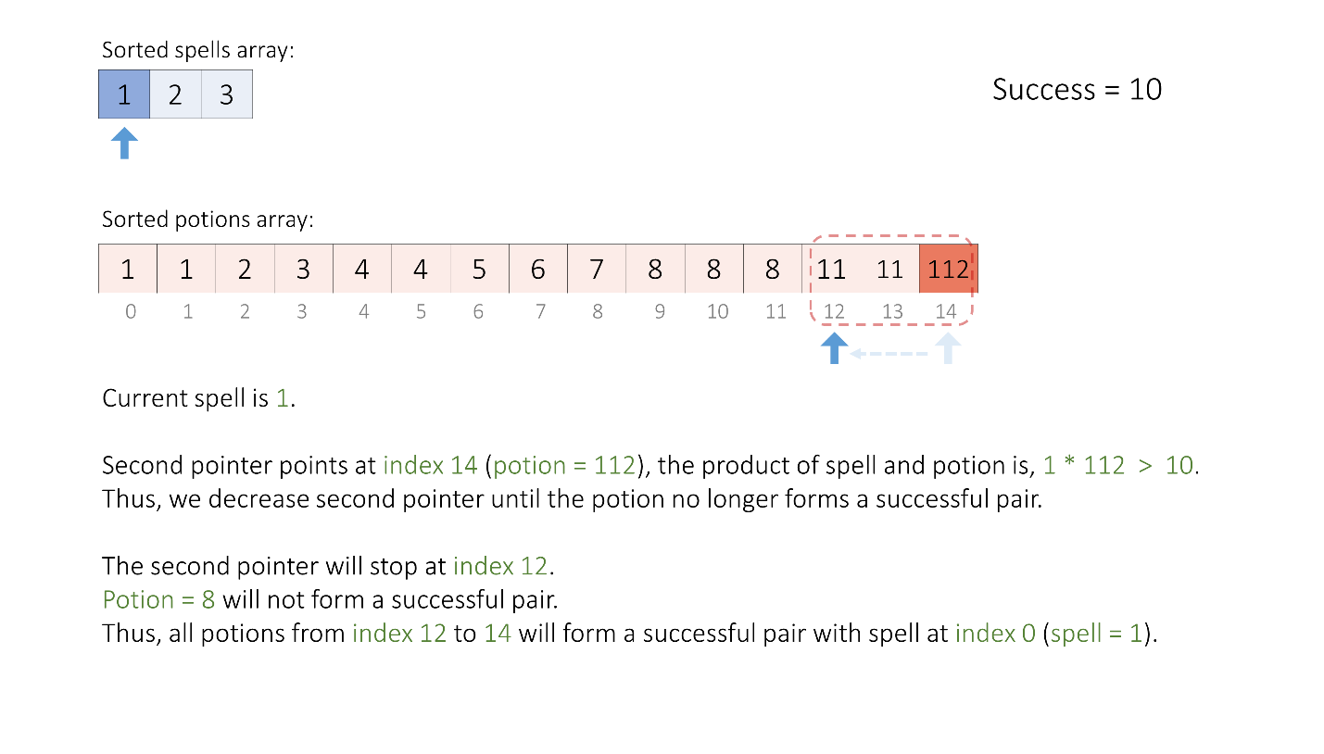

Now, when we move to the next spell, as the next spell is greater than the previous spell, the potions which made a successful pair with the previous spell will also form a successful pair with the current spell (as we incremented one number in the product of two numbers, thus their product's result will also increase; it will be greater than success).  
Thus, we just need to continue decreasing the second pointer from its previous value until it points to the minimum required potion for the current spell again to count the potions.

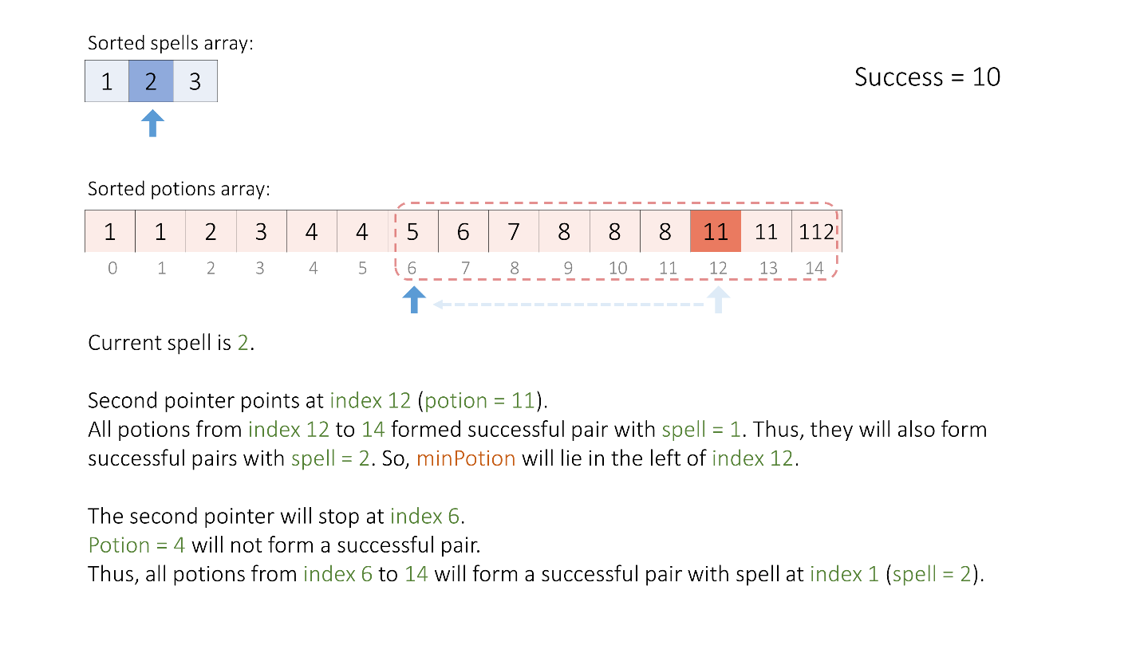

We continue the above steps until we cover all the spells.

**Algorithm**

1. Create an array of pairs sortedSpells with the first element of each pair being a spell strength and the second element being its original index in the spells array.
2. Sort the sortedSpells and the potions arrays in ascending order.
3. Initialize variables:
   * answer, an array of size spells.size() to store the result.
   * m, length of the potions array.
   * potionIndex, an integer initialized to m - 1 to keep track of the index of the current potion in the potions array.
4. For each spell and its original index in the sortedSpells array:
   * While we have not run out of potions and the product of the current spell strength and the strength of the potion at the potionIndex is greater than or equal to success, decrement potionIndex by 1. We stop at minPotion for the current spell.
   * Calculate the number of successful pairs possible for the current spell as m - (potionIndex + 1) and store the result at the index position in the answer array.
5. Return the answer array which contains the number of successful pairs for each spell.

**Implementation**

class Solution {

public:

    vector<int> successfulPairs(vector<int>& spells, vector<int>& potions, long long success) {

        vector<pair<int,int>> sortedSpells;

        for (int i = 0; i< spells.size(); ++i) {

            sortedSpells.push_back({ spells[i], i });

        }

        // Sort the 'spells with index' and 'potions' array in increasing order.

        sort(sortedSpells.begin(), sortedSpells.end());

        sort(potions.begin(), potions.end());

        vector<int> answer(spells.size());

        int m = potions.size();

        int potionIndex = m - 1;

        // For each 'spell' find the respective 'minPotion' index.

        for (const auto& [spell, index] : sortedSpells) {

            while (potionIndex >= 0 && (long long) spell * potions[potionIndex] >= success) {

                potionIndex -= 1;

            }

            answer[index] = m - (potionIndex + 1);

        }

        return answer;

    }

};

**Complexity Analysis**

Here, nn*n* is the number of elements in the spells array, and mm*m* is the number of elements in the potions array.

* Time complexity: O(nlog⁡n+mlog⁡m)O(n \log n + m \log m)*O*(*n*log*n*+*m*log*m*)
  + We create an array sortedSpells which takes O(n)O(n)*O*(*n*) time, and then sort the sortedSpells and potions arrays which take O(nlog⁡n)O(n \log n)*O*(*n*log*n*) and O(mlog⁡m)O(m \log m)*O*(*m*log*m*) time respectively.
  + Then using two pointers we iterate on each element of the sortedSpells and potions arrays once which will take O(n+m)O(n + m)*O*(*n*+*m*) time.
  + Thus, overall we take O(nlog⁡n+mlog⁡m)O(n \log n + m \log m)*O*(*n*log*n*+*m*log*m*) time.
* Space complexity: O(n+log⁡m)O(n + \log m)*O*(*n*+log*m*) or O(n+m)O(n + m)*O*(*n*+*m*)
  + The output array answer is not considered as additional space usage.
  + But we create an additional array sortedSpells which will take O(n)O(n)*O*(*n*) space.
  + And some extra space is used when we sort the sortedSpells and potions array in place. The space complexity of the sorting algorithm depends on the programming language.
    - In Python, the sort() method sorts a list using the Timsort algorithm which has O(m)O(m)*O*(*m*) additional space where mm*m* is the number of the elements.
    - In C++ and Swift, the sort() function is implemented as a hybrid of Quick Sort, Heap Sort, and Insertion Sort, with a worst-case space complexity of O(log⁡m)O(\log m)*O*(log*m*).
    - In Java, Arrays.sort() is implemented using a variant of the Quick Sort algorithm which has a space complexity of O(log⁡m)O(\log m)*O*(log*m*).
    - In JavaScript, the space complexity of sort() is O(log⁡m)O(\log m)*O*(log*m*).
  + Thus, sorting uses either O(log⁡n+log⁡m)O(\log n + \log m)*O*(log*n*+log*m*) or O(n+m)O(n + m)*O*(*n*+*m*) space.
  + In Swift, we need to create an additional array for keeping sorted potions which will take an additional O(m)O(m)*O*(*m*) space.
  + So, overall we usem O(n+log⁡n+log⁡m)=O(n+log⁡m)O(n + \log n + \log m) = O(n + \log m)*O*(*n*+log*n*+log*m*)=*O*(*n*+log*m*) or O(n+n+m)=O(n+m)O(n + n + m) = O(n + m)*O*(*n*+*n*+*m*)=*O*(*n*+*m*) space.